REST and NodeJS intro exercises
- Using the code from a previous exercise, utilise this in an API:
Write a function that accepts a value in degrees centigrade and returns the degrees Fahrenheit or visa versa. The formula is:
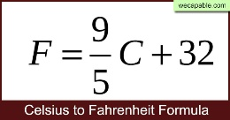
Devise one or more endpoints to specify a temperature that returns that temperature after conversion from degrees C or degrees F
- Using the tax solution from a previous exercise, create an API that takes an annual salary and returns the tax due. Limit the salary to £100,000
- The format of multi-word names can be multiWord, multi_word, multi-word, the recommended approach for web API multi-word services is to use lower case and hyphen. The words should also be nouns, as they refer to resources, not verbs.
You should provide four endpoints to get date and time. Typical responses are shown:
Path: ‘/time-str’
Response: "14:49:09"

Path: ‘/time-obj’
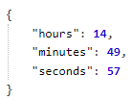
Response:

Path: ‘/date-str’
Response: Fri Aug 18 2023
Path: ‘/date-obj
Response:
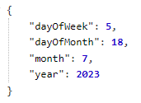
Look up the Date object and its methods.
- Using the provided pricelist.json, create API endpoints to provide the following functionality:
- Return all items
- Return all items of the same type. E.g. Laptop
- Return all items in a provided price range
- Add a new item to the list
- Delete a specified item from the list
- Update the price of an item and return the item showing its new price

